**Assignment Day 2**

Task1(Expected time : 25 Minutes)( Basic Designing)

Open a new Tableau workbook and connect to C:/data/Tableau session/Global Superstore 2016.xlsx. Select orders as your table by dragging it on to canvas area and perform following activities:

1. Go to Sheet1 and Find out number of orders placed, total Sales, total profit, total discount in a single click.Name this sheet as KPIs.
2. Add another sheet and find sum of sales by each category as Bar chart, sort the result from higher sales to lower.Name the sheet as Category Sales.
3. Sheet Title should be ‘ Category Wise Sales’ and it should be in Bold Letters, in center and Fint Size should be 20.
4. Each Bar should have a different color.
5. Sales Value should be displayed on every bar.
6. Whenever the cursor pointed over to any bar, it should display Category, Sales and profit.
7. Add another sheet and design a stacked chart something like below

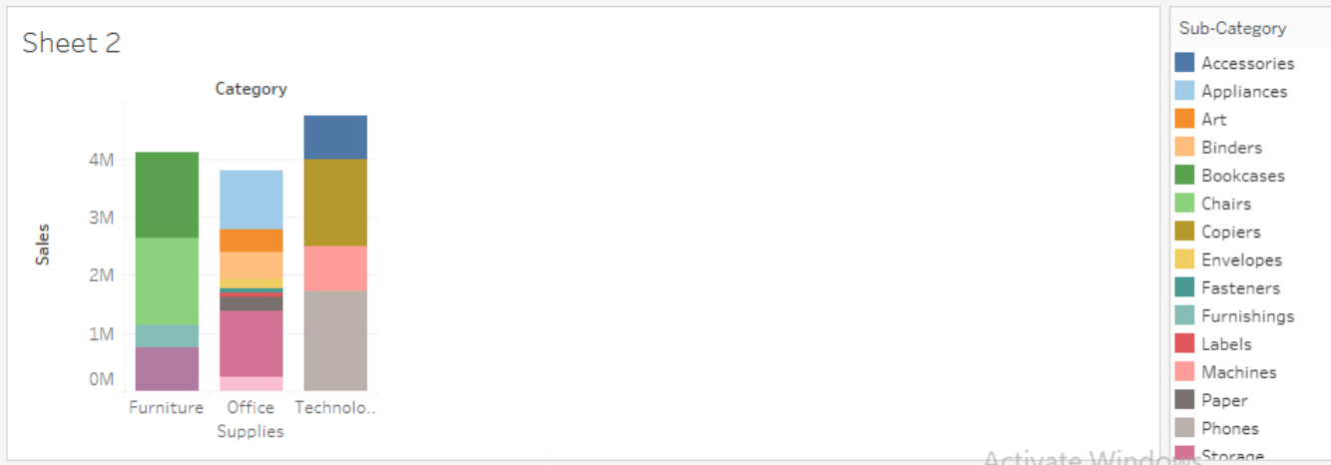

1)Category Labels( Furtinure,Office Supplies and Technology) should be in bold letters and Blue color

2) Worksheet Backgroud should be light purple.

3) Change The sheet title ‘ category and Subcategory wise Sales Report’.

4) Display percentage of sales in each subcategory(like below). The Percentage is as per Category not as entire sales. For example 15.79% is the percentage of total sales of Accessories in Technology.

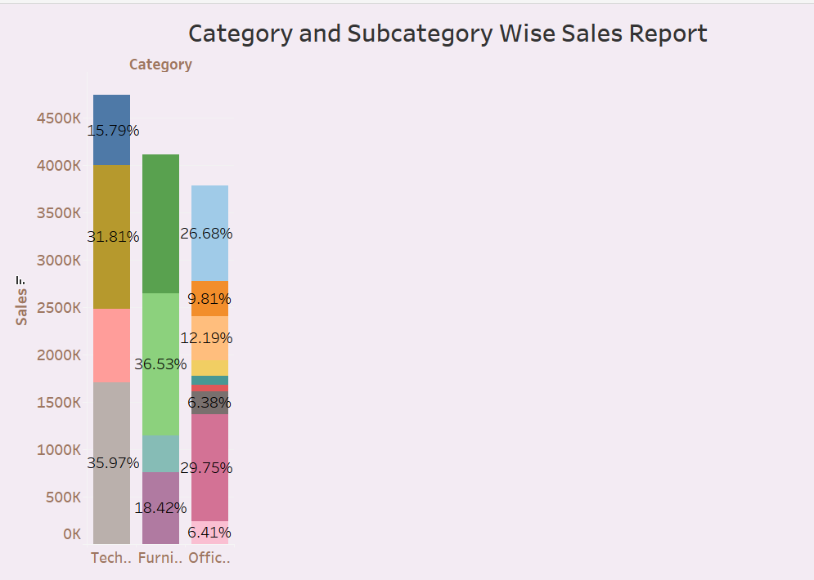

Save this workbook as simpledesign.twbx

**Task 2 : Expected Time 25 Minutes( Hierarchy and Groups)**

**Open simpledesign.twbx and do the following**

1. Analyze the sales data year/qtr/month wise in a single sheet. There should be drill down.
   1. Sheet Name and Title should be Sales as per Time series
   2. Use Line Chart , there should not be any grid lines in line chart background.
   3. Print Sales Values as Labels
   4. Background Color Should be light green
   5. Axis Values should not include zero.

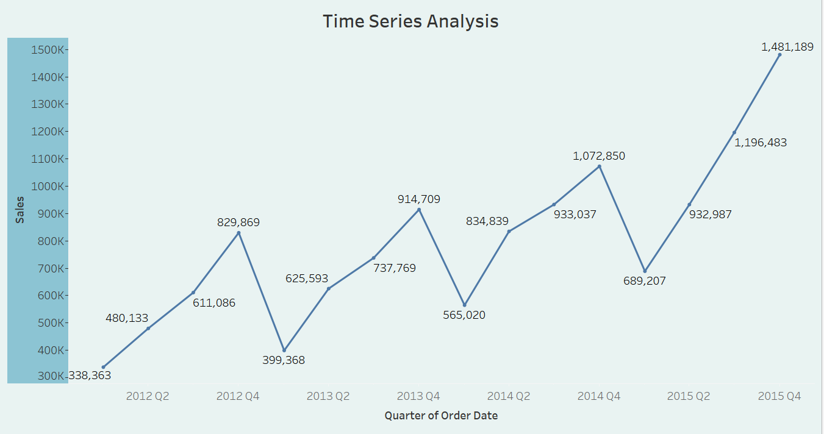

1. Add another sheet and Analyze the sales data Category/sub category/Product Name wise using single sheet .Format should be exactly like previous sheet. Sheet title should be Product Wise Detailed Report.

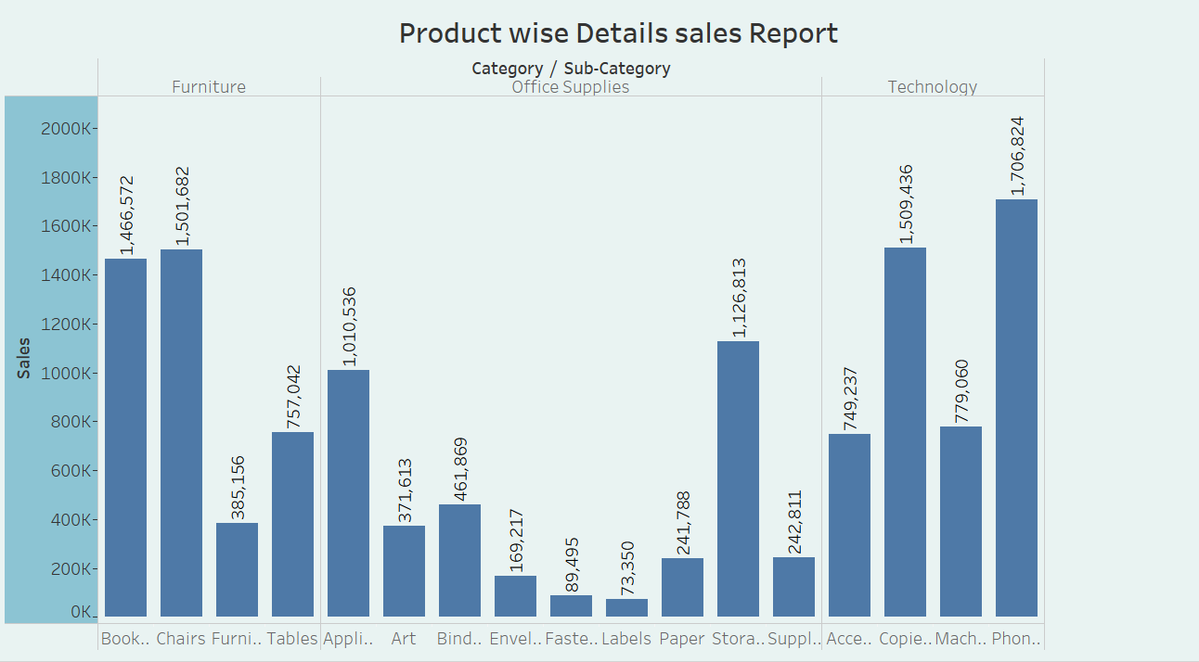

1. Add another sheet, name it as Five Eyes vs Others ,Create a group of United States,Australia,Canada, New Zealand and UK, compare its sales with other countries. Format should be like previous sheets.

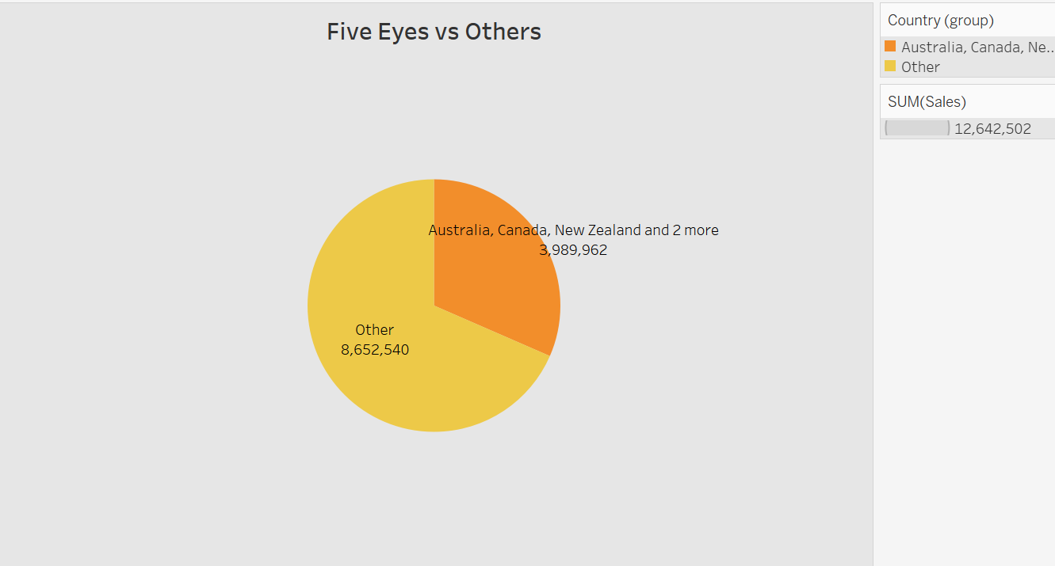

Task 3 15 minutes

Design a Map chart with Pie like below

It is for states of US, colors in states is showing Profit and pie in states is showing category wise sales.

